F.07 -

Functionality
This program calculates the balance carried forward for customers and/or vendors. The balances of the previous year are carried forward to the New Year. If the account has not yet been posted in the new year and no balance carried forward has been carried out for this account, the account is opened in the new year with the 1st balance carried forward; otherwise, the balance carried forward of the account is stored in the new year if changes result. This program should be run at the beginning of the new fiscal year. If the program is already run at the end of the last fiscal year, postings which are posted after this to the last fiscal year, do not result in automatic adjustment of the balance carried forward because it is not a "posting to a previous year". In such a case, it is necessary to let the program run again after these postings to carry forward the postings entered later. The program can be started as often as desired.

Scenario
This program should be used on the beginning of the next fiscal year. Also you should run this program in every case when the discrepancies occur (end balance of the vendor or customer account for the previous fiscal year is different that the opening balance for the current year).

Prerequisites
Customer or Vendor Master Records

Menu Path | Accounting → Financial Accounting → Accounts Payable → Periodic processing → Closing → Carry forward → F.07 - Balances
Transaction Code | F.07

1. Double click on F.07 – Balances.

Carry Forward Receivables/Payables

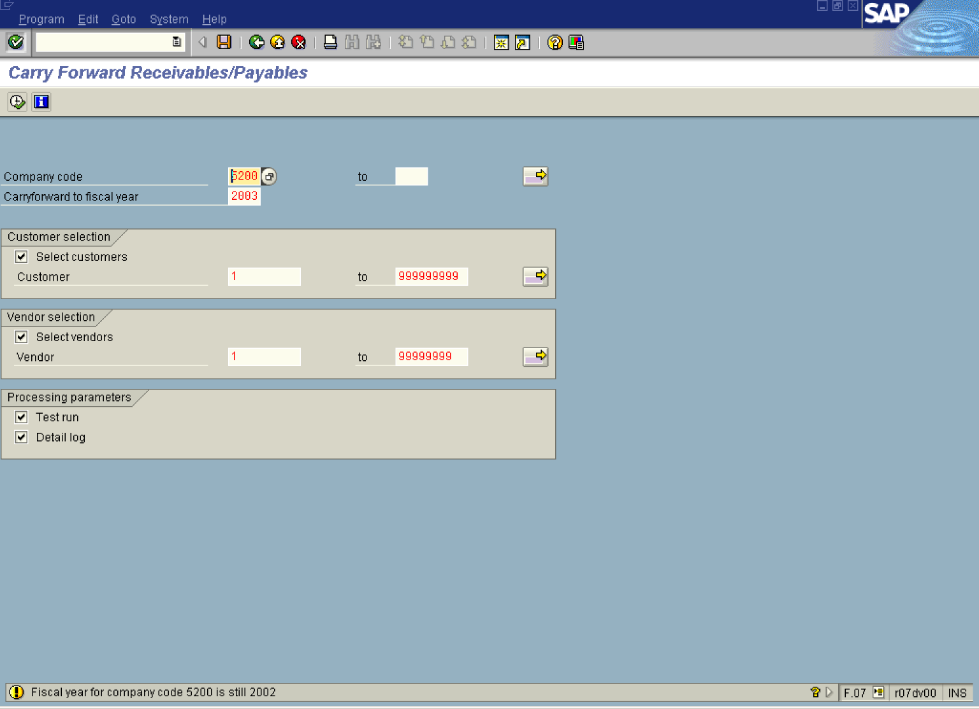

2. Update the following fields:

Field Name | Field Description | Values
Company code | Code identifying a separate legal entity for which a separate set of accounts is maintained for external reporting purposes | Example: 5200
Carryforward to fiscal year | Enter here a number of the fiscal year you want to transfer the balances to | Example: 2003

 By default the program is in the test mode. Always try this program first in the test mode, check the results and then run it again in the production mode.

3. Click Select customers .

4. Update the following fields:

Field Name | Field Description | Values
Customer | Code identifying a customer account | Example: 1
to |  | Example: 999999999

5. Click Select vendors .

6. Update the following fields:

Field Name | Field Description | Values
Vendor | Code identifying the vendor account | Example: 1
to |  | Example: 99999999

7. Click Detail log Button to print additional program log

8. Click Enter Button to confirm your entries.

9. To carry forward balances, click Execute Button . The system will display a report:

Carry Forward Receivables/PayaFor the Year 2003 Test Run

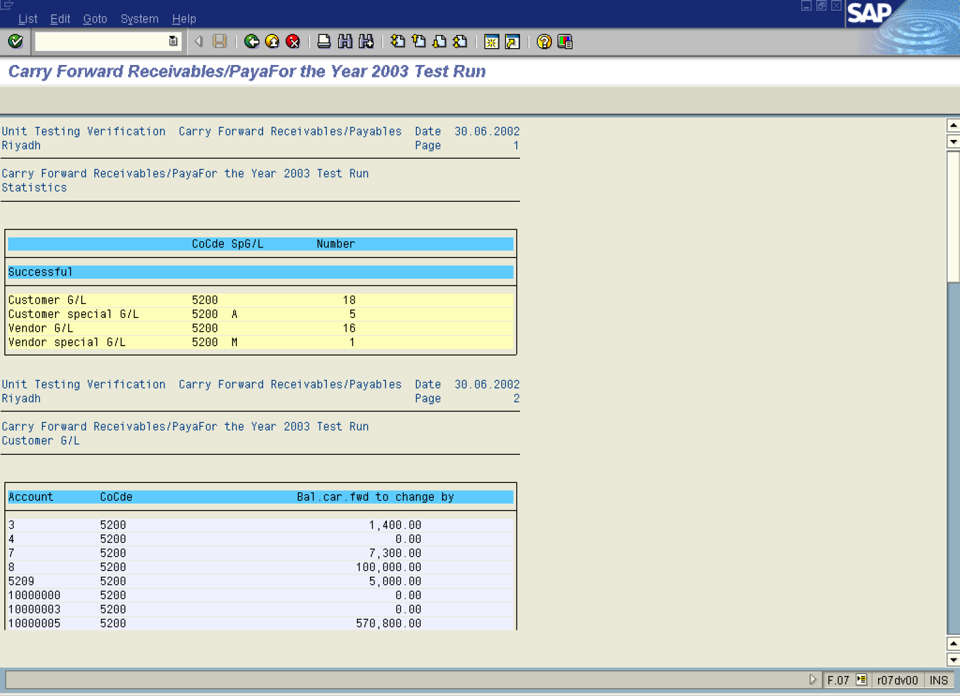

10. Click Back and deactivate the Test run radio button.

11. Click Execute to carry forward balances in the production mode.

